28 Nov 11

MEMORANDUM

From: MIDN 1/C Shafiq Ladha, USN

MIDN 2/C Matthew K. McVay, USN  
To: PROF. Parikh

Subj: shuttel arm position Lab

1. **schematic:**

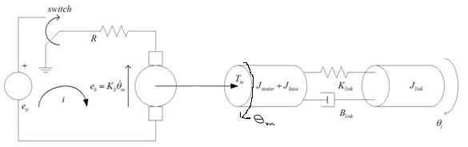

1. **STATE SPACE MODEL**:

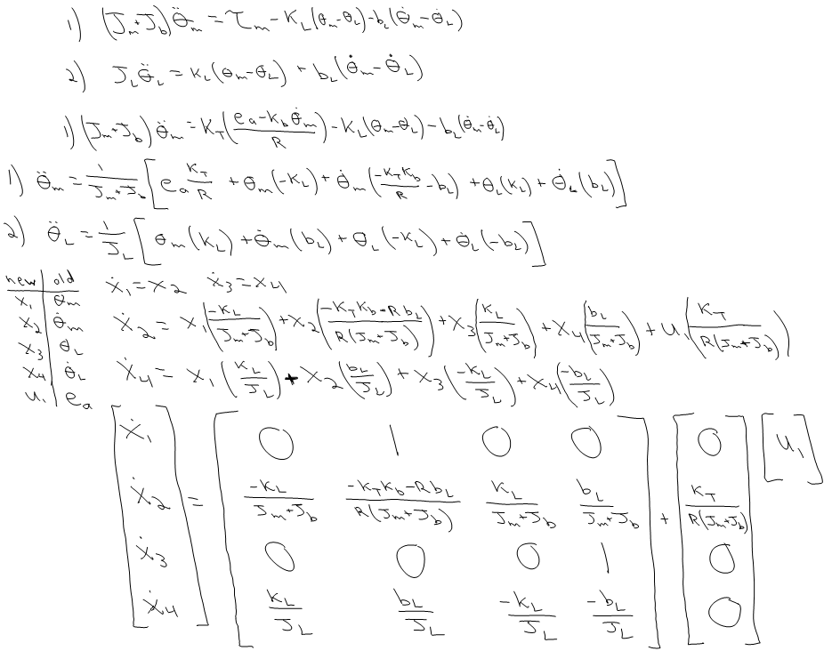

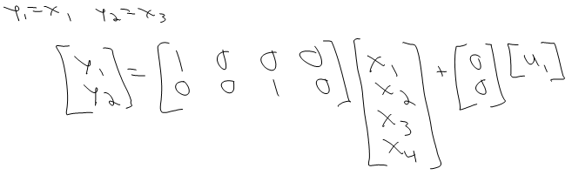

1. **PARAMETERS:**

|  |  |  |  |  |  |  |  |
| --- | --- | --- | --- | --- | --- | --- | --- |
|  | Jm | R | KτB | J­L | BL | KL | Jb |
| Nominal Value |  | 2.5 | 0.6 | 0.0019 | 0.0003 | 1 |  |
| Measured Value | 0.0030727 | 2.9 | 0.614 |  |  |  | 0.0004503 |

1. **COMPUTATIONS:**
$$speed=\frac{π rad}{0.3 sec}=10.472 rad/sec$$

$$e_{a}=\frac{speed}{K_{DC}}=speed*K_{τB}=6.43V$$

$$width=\frac{0.3 sec}{5 sec}*100\%=6\%$$

2. **MODEL VALIDATION:**

|  |  |  |  |  |  |  |  |
| --- | --- | --- | --- | --- | --- | --- | --- |
|  | ea | Pulse Width | Settling Time | % error | DC gain (exp) | Max Arm Position | Max %OS |
| Exp | 6.42 | 0.3 | 0.67 | -0.3% | 1.629 | 196o | 9.2% |
| Sim | 6.42 | 0.3 | 0.8 | -2.04% | 1.674 | 192o | 6.67% |

1. **PLOTS:**

 

 

1. **DISCUSSION:** The position error was calculated for the simulation against the experimental position data during steady state. The model was about 2% off in predicting position error, and it was about 2.5% off in predicting %OS. The model was therefore a better predictor of position error than percent overshoot. The model for both the arm and the motor gave positions that had a slightly lower and slower response, but the DC gain was fairly well matched. This shows that KτB was measured fairly accurately, but either some of the other parameters were off, or the linear approximation threw off our model. In either case, the arm’s position lagged the motor position and had a greater settling time as expected (the arm was driven by a spring attached to the motor). We did assume that the viscous friction and inductance of the motor were negligible when calculating the motor parameters on the previous lab, but those would have delayed the peak overshoot of the system in comparison to the model, and the result was in the other direction, so those assumptions were valid. The largest phenomenon that was neglected, however, was probably the linear assumption of the system in creating our model. One of the largest sources of error, however, was most likely the fact that we had to run our experiment on a system different than the one we took measurements on due to a bad board.

Very Respectfully,

Shafiq Ladha

MIDN USN

Matthew K. McVay

MIDN USN